# Report on Burrito King Application Development

Contents

Report on Burrito King Application Development 1

Introduction 2

Background 3

Objectives 4

Application Overview 4

Implementation Details 5

User Registration and Login 5

Dashboard 6

Order Placement 6

Viewing and Managing Orders 6

VIP Features 7

Data Persistence 7

Validation and Error Handling 7

Advanced Features 8

Order Export 8

GUI Consistency 8

Screenshot 8

Conclusion 17

References 18

# Introduction

The Burrito King application is a Java-based more than that project designed taking into attendance of COSC1295 Advance Programming course unit. The application is intended to supply a way of interaction of users with a manageable system for taking restaurant orders, exploiting JavaFX for a graphical user interface, and preserving data using CSV files for data persistence and the management of data. Established according to the OOP principles, the application provides the application of software development techniques, like SOLID principles, and object-oriented patterns like MVC and Singleton.

The main features of Burrito King App will enable the users to register, login, view order, make profile custom, and track their orders. Also, VIP customers have a section that provides for packages that include discounted fast food and a credit-for-cash type of reward system. The application is Data-oriented and promotes user data handling robustness in that the user credentials and order details may be got from CSV files during the start-up and update them as and when there is a change.

This project with particular focus on front-end and back-end components which ensure their smooth integration providing thoughtful and interactive experience for end users. It also consists of these and validation & error handling mechanisms that have integrity controls and ensure that clear responses are delivered to users. To conclude, this hypothetical Burrito King application unites the aforementioned key points demonstrating the process of building a real-life and user-friendly application which is maintainable and functional.

# Background

the Burrito king application is developed under the supervision of the lecturer of COSC1295 in Advanced Programming at RMIT University The target of this class is introducing into students advanced techniques for software development, which will have OOP, data persistence and GUI development as the central point. The assignment is a real-life simulation of the whole restaurant ordering system where the student will be able to transfer his/her theoretical knowledge into practice thus have a chance to show competency in designing and implementing complex software.

The application makes use of JavaFX for the GUI, the interface with the modern user designs in mind. To conclude, it also employs data persistence which uses CSV (comma-separated values) files in order to guarantee that such information as user and order data is consistently stored and retrieved. The application incorporates all the major features such as user registration, login, profile management, ordering products and viewing, apart from having extra features for VIP users.

Through this project, then, the students would have an in-house opportunity of experiencing an actual application development, combining front and back end concepts, as well as the principles of designing accessible and flexible code. In particular, the application project demonstrates how utilizing validation and error handling makes your software strong and successful among your users

# Objectives

The main objectives of the Burrito King application are:

User-Friendly GUI Development: Design an interesting, responsive graphical user interface using JavaFX to provide good navigation/ interaction access to users Among these processes are frames for the instances of user registration, login in, profile management and placing an order.

Data Persistence: Make sure that users, order, and role information are stored with the option to use CSV files. This implies that data is loaded from files onto the applications or vice-versa, so with every session the files are updated with the most recent data correctly.

Object-Oriented Design: The use of mobile-oriented design principles should be applied to make the code modular, maintainable and scalable. These should be practiced through implementing SOLID principles and design patterns.

Core Functionality Implementation: Deliver the base functionalities like a registration form, sign in section, a profile section, and order management section. Although these features must be robust, reliable, and user-cantered, remain the necessary feature.

Advanced Features for VIP Users: Provide additional features for VIP users which consist of discount packages, credit points based reward system and the option to avail credit points by giving discounts. These characteristics are a strong point in its favour and produce the positive effect on users themselves.

Validation and Error Handling: Implement a data integrity validation scheme with error handling mechanisms to ensure accurate data interpretation and provide user friendly feedback, helping users improve their skills and have enhanced experience.

These goals of mine imply that the Burrito King app is a hands-on undertaking with all aspects reflecting the importance of advanced programming skills and technologies (“JavaFX Input Validation Textfield” n.d.).

# Application Overview

The Burrito King application is structured around several key classes and functionalities:

**User Class**

The User class will become a user class of the app. It is a set of traits including the username, password, first name, last name, membership status VIP class, e-mail and credits that are joined to the person. This class has been developed with the help of the authentication methods; user updates, VIP upgrading, and credit facilities.

**Food Item Class**

The Food Item class is the class that joins with menu items. Item like that has a name and a price. This class is used to manage the content if the shopping basket as well as display the items in the shopping basket.

**Order Class**

The Order class encloses the information about an order, including the items, status, total price and time and date collection represent, order date respectively. This class supports functionality such as the generation of the orders, status updates, and the business data export in CSV.

**Application Class**

The main part of the software, Burrito King App is responsible for the user interface managing and interactions between a user, order and the backend data storage.

# Implementation Details

### User Registration and Login

The initial user experience of the Burrito King application would involve a registration and login feature to secure access, guarantee each user's personalized experience. Two fields of information are captured during registration including a user’s unique username, a password, the first name and the last name. Validation functions that check if the entries and the preferred username is not null and will not be duplicate, is included in the application. This pluralism check is crucial as it makes sure the conflict prevention and that the user data is not corrupted.

Subsequently, the credentials of the users that are verified are kept in a CSV file, and this file is the main tool for the persistence of the data. Besides, the “data-directed storage approach is a blessing that simply works well for storing and managing the user’s data. The application initializes itself at start by reading the CSV file and loading user info for safe keep hence no glitch will occur in starting.

As soon as the user attempts to log in, the application runs a check to crosscheck the credentials entered against those stored for the logged in user. The user is thus directed to the dashboard if the authentication details check out. Enter the details for the registration or an error message will be displayed to retry the process with the correct details of the registration.

### Dashboard

Within a click to login, your dashboard becomes the command centre to access diverse features of the online platform. The home dashboard displays a personalized greeting message for the user, which includes the user's name in both first and last names. It also gives the details of user’s order(s) which are currently at the stage of processing or in the process of shipping.

From the dashboard, users can access several key features through dedicated buttons: bird call: profile editing and placing order, viewing order and export order, and upgrade to VIP (if have), and logout. Any key on the keyboard will give a specific action or form, like managing all the functions smoothly and better user interface.

### Order Placement

The main cheat of the Burrito King application is ordering. Clients can have a look at a menu and make an order involving the items they prefer. Every item provided can have the ordered quantity specified by users. This tool’s function is determined by its ability to automatically total the price of the order as one proceeds selecting the items and quantities.

As per VIP users automatic discount rate is added to the total price the VIP status paying of course become very much attractive priority. The system makes certain that during the payment process users are providing false payment information which is approved by the app to see whether the details are realistic. This validation step is similar to a real-world environment and as such, it delivers what it is meant for.

### Viewing and Managing Orders

Users through their account can have a complete record of their orders with a complete history of their orders. Date and time of the order, detailed status, and the price being the valuable record components. g. What terms such as, "bill to grid," "waiting to be picked," "in transit," or "returned" means, as well as what time is indicated in the "collection date." Recent orders reach earliest this way, as their presence is towards the top.

The application permits customers to superintend their cabin orders with help of a special button for picking up or cancelling their orders. Respectable status checks are designed to guarantee the functionality of the system where one cannot enter a viewed order to be cancelled or dishes to be added (“JavaFX Food ordering application” 2023).

### VIP Features

Non-VIP users can decide opt-in for a level-up to the VIP status by accepting to get access to the promotional emails and by giving up a valid email address. After it is upgraded the VIP users are able to gain more, like getting rebates for the orders they place and earning the credits for every amount that they have spent. These credits can be used to purchase items in further orders, which eventually turns into something customers always pursue while interacting with the app.

### Data Persistence

A permanent storage of data is essential to the Burrito King application. User and order data are stored in CSV format. The process of reading these files when the application starts and also updating already present data is carried out whenever a change occurs. Therefore, this approach enables the data to remain in sessions, so that no matter how many times you open the website, you will always find all the necessary data.

### Validation and Error Handling

The app involves complete validation of user’s data and information to ensure the reliability of user input. In relation to this, the servers check whether the required fields and data in the registration form, login input and order placement is complete and correct, the servers also checks for correctness of the payment details. These error messages become a guide for the user to correct any mistake allowing the user experience to become more usable.

Additionally, the program is designed to recover from I/O file errors, thereby protecting the program against the unexpected obstacle of reading and writing of CSV files to the users. Unwavering error handling is responsible for ensuring that the application is reliable and the user-friendly, even in the eventuality of out-of-imagination error cases.

In brief, the application integrates a heavy usage of functionally and an easy to use design alongside data management so that it will really be easy to use to the users. During a considerable effort to designing functionality like registration, login, order management, loyalty features, and data persistence, the app represents a real-life software development implementation (“Getting Started with JavaFX: About This Tutorial | JavaFX 2 Tutorials and Documentation” 2013).

# Advanced Features

**VIP Ordering and Credits**

VIP users are entitled to choose the bundle of meals that are priced lower and if they spend more, they may accumulate points for every dollar spent. Customers may get order price credits that can be used as loan payment deduction certificates. The deduction amount is calculated in the actual paid amount.

### Order Export

Users are able to save their order history to their PCs, selecting a specific range of orders and invoice details (select order range and invoice details). This greatly improve user interface to suit those who want to keep track of their ordered products.

### GUI Consistency

In spite of browser differences and device particularities, the application ensures a uniform look and feel throughout different forms and tasks. Every window is unambiguously labelled, and the other elements fall within a similar styling which in its turn increments UX (user experience) (“JavaFX Tutorial” n.d.).

# Screenshot

***Login***

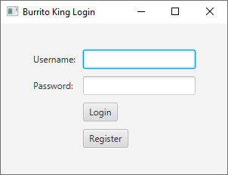

***Create Profile***

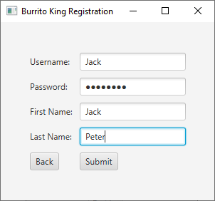

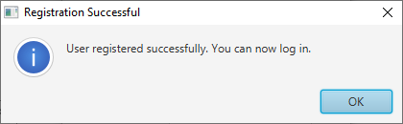

***Login Vakidation***

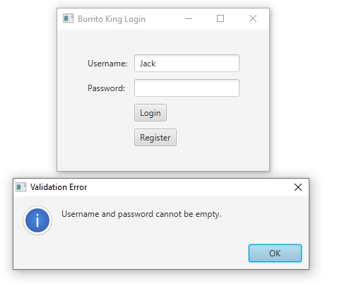

***After customer validation***

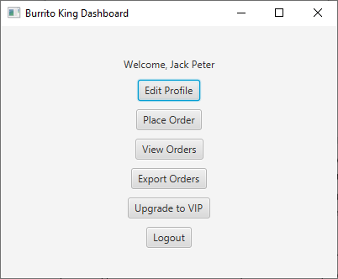

***Place order***

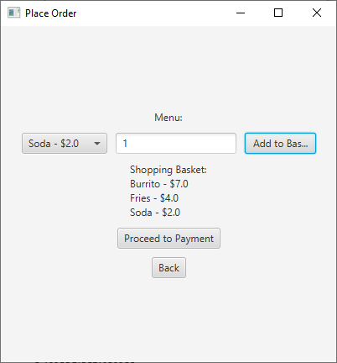

***Credit card***

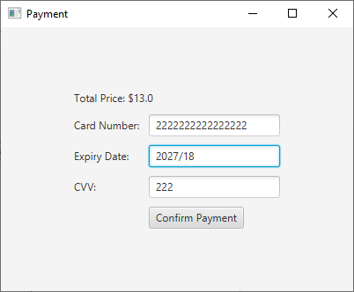

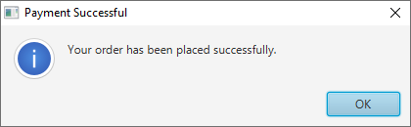

***View Order***

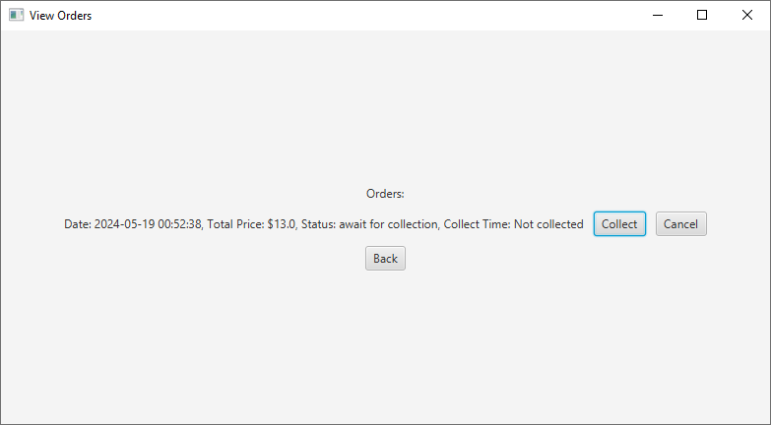

***Collect Order***

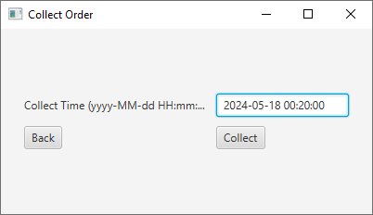

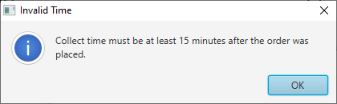

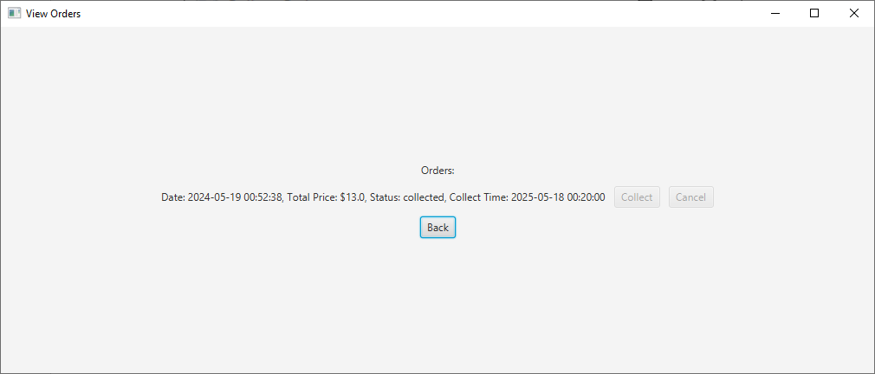

***Upgrade VIP***

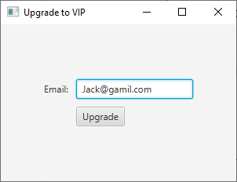

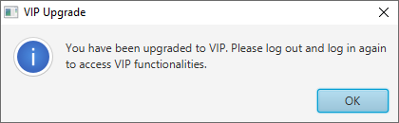

***Relogin***

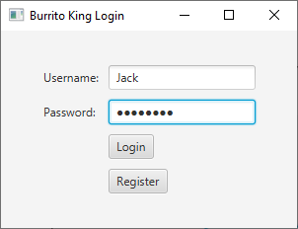

***Discount***

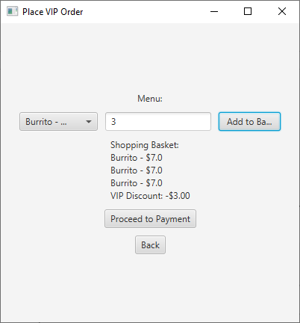

***After discount***

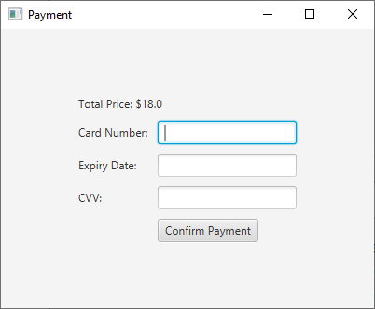

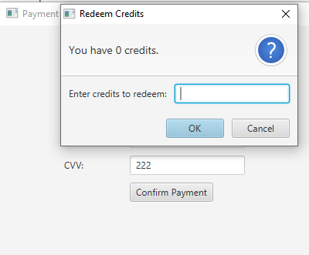

***Export***

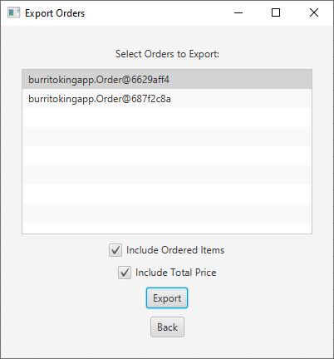

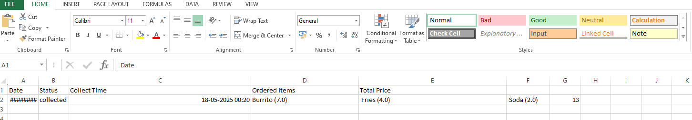

***Edit profile***

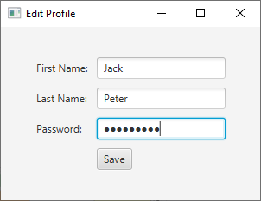

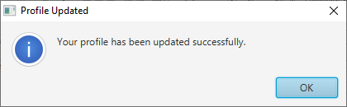

***Logout***

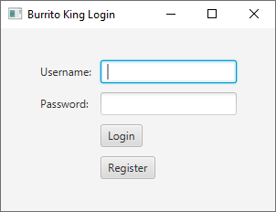

# Conclusion

The Lolo King application proves that the JavaFX is efficiently used for GUI, the system follows the object-orientation approach and data persistence is completed using _CSV_\_files_. The great thing is that the project demonstrates that frontend and backend could be integrated together and last but least gives the nice user experience. VIP features’ incorporation and thorough pre-launch tests make the application capable of meeting the advanced requirements and delivering of extra value to the end users.

The project allows to complete the course prerequisites also provides profound examples of the development’s application to the real world with priorities in user experience, data integrity, and maintainability. The skills mastered and key lessons gained in the development of the software are central to future projects.

# References

BRsmoverBRsmover  88722 gold badges1111 silver badges2121 bronze badges *et al.* (1961) *JavaFX input validation textfield*, *Stack Overflow*. Available at: https://stackoverflow.com/questions/30935279/javafx-input-validation-textfield (Accessed: 20 May 2024).

*Javafx 2.2.40* (2013) *Getting Started with JavaFX: About This Tutorial | JavaFX 2 Tutorials and Documentation*. Available at: <https://docs.oracle.com/javafx/2/get_started/jfxpub-get_started.htm> (Accessed: 20 May 2024).

*JavaFX tutorial* (no date) *Tutorialspoint*. Available at: https://www.tutorialspoint.com/javafx/index.htm (Accessed: 20 May 2024).

*JavaFX food ordering application* (no date) *w3resource*. Available at: https://www.w3resource.com/java-exercises/javafx/javafx-user-interface-components-exercise-12.php (Accessed: 20 May 2024).